**Assignment IU 02-1 Submission**

**Explore the Azure Machine Learning workspace**

Azure Machine Learning provides a data science platform to train and manage machine learning models. In this lab, you'll create an Azure Machine Learning workspace and explore the various ways to work with the workspace. The lab is designed as an introduction of the various core capabilities of Azure Machine Learning and the developer tools. If you want to learn about the capabilities in more depth, there are other labs to explore.

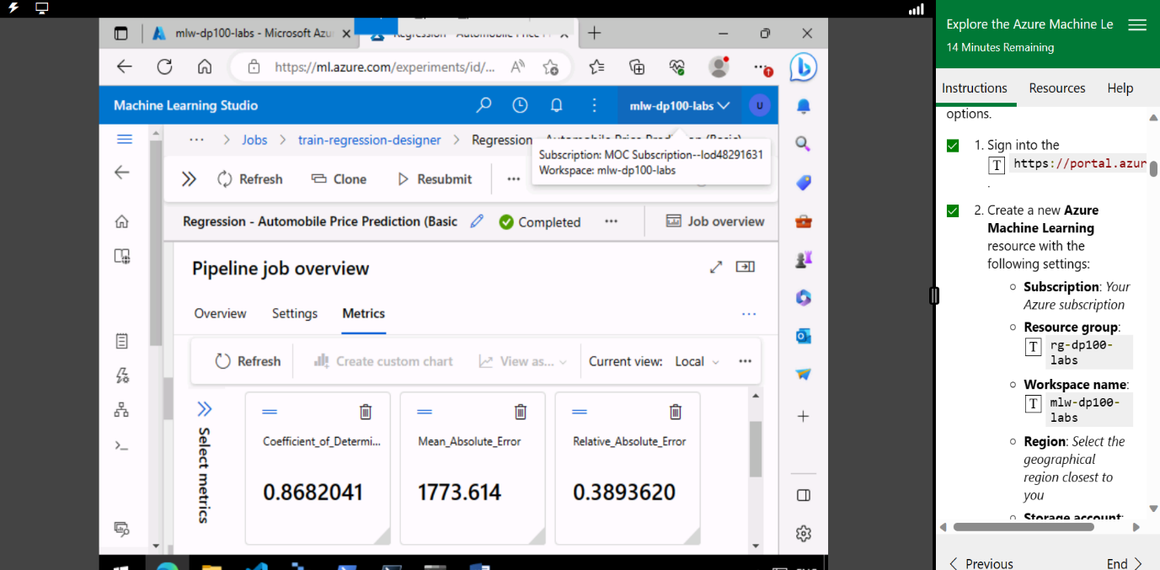

In summary, provisioning an Azure Machine Learning workspace is a foundational step for setting up a machine learning environment. It provides a unified platform for resource management, collaboration, version control, security, and scalability, ultimately enhancing the productivity and effectiveness of data science and machine learning projects.